**JSS 2**

**CHECKPOINT MATHEMATICS NOTE**

**FIRST TERM**

**Week 1: Decimal Operations**

**Week 2: Ratios & Proportions**

**Week 3: Equations & Inequalities**

**Week 4: Sequences & Functions**

**Week 5: Graphing Linear Functions**

**Week 6: Geometry - Quadrilaterals & Circles**

**Week 7: MID TERM BREAK**

**Week 8: Area & Volume**

**Week 9: 3D Geometry**

**Week 10: Angles & Bearings**

**Week 1: Decimal Operations**

**Multiply Decimals by Decimals**

**Concept:**  
To multiply decimals, multiply the numbers as if they were whole numbers. Then, count the total number of decimal places in both original numbers and place the decimal point in the product accordingly.

**Examples:**  
a) 0.4 × 0.3 = 0.12

b) $5.96×0.35$

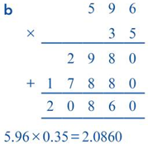

**Divide Decimals by Decimals**

**Concept:**  
To divide a decimal by another decimal, multiply both the dividend and the divisor by the same power of 10 to make the divisor a whole number. Then, perform the division as usual.

**Examples:**  
a) 0.6 ÷ 0.2 = 3

b) $3.468÷0.8$

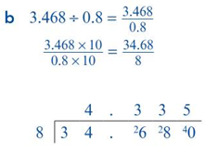

**Ratio/Direct Proportion**

**Concept:**  
A ratio compares two quantities. Direct proportion means that as one quantity increases, the other increases at the same rate.

**Examples:**  
1) If 2 pencils cost $1, then 4 pencils cost $2.

2) 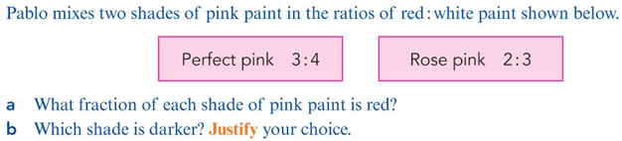

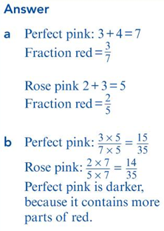

ACTIVITIES: Cambridge Lower Secondary Mathematics Workbook 8

* 1. Ex. 4.2, pg 53, No. 12
  2. Ex. 4.3, pg 57, No. 12
  3. Ex. 12.3, Pg 155, No.2 & pg 157, No.11

ASSIGNMENT: Cambridge Lower Secondary Mathematics Workbook 8

1. Ex.12.3, pg 158, No.15 and 16
2. Ex. 4.2, pg 54, No. 16
3. Ex. 4.3, pg 57, No. 14

**Week 2: Ratios & Proportions**

**Simplify Ratios (Different Units)**

**Concept:**  
Convert all quantities to the same unit before simplifying the ratio.

**Example:**  
3 meters : 200 centimeters  
Convert 3 meters to 300 centimeters: 300 cm : 200 cm  
Simplify: 3 : 2

**Divide Amounts into More Than Two Ratios**

**Concept:**  
Add the parts of the ratio to find the total number of parts. Then, divide the total amount accordingly.

**Example:** Dave, Ella and Jia share their electricity bills in the ratio 3:4:5. How much does each of them pay when their electricity bill is $168?

**Rearrange Formulae**

**Concept:**  
Change the subject of a formula by performing inverse operations.

**Example:**  
Given A = bh, make h the subject:  
h = A ÷ b

ACTIVITIES: Cambridge Lower Secondary Mathematics Workbook 8

* 1. Ex. 12.2, pg 151, No.4

ASSIGNMENT: Cambridge Lower Secondary Mathematics Workbook 8

1. Ex. 12.2, pg. 153, No. 10

**Week 3: Equations and Inequalities**

## Constructing Expressions

Translate word problems into algebraic expressions.  
Example:  
"Three more than twice a number"  
2x + 3

## Using Expressions and Formulae

Substitute values into expressions and formulas.  
Examples:  
a) If A = lw, find A when l = 5 and w = 3  
A = 5 × 3  
A = 15

b) Use the formula $f=\frac{w}{p}$ to work out the value of f when w=60

## Expanding Brackets

Multiply each term inside the bracket by the term outside.  
Examples:  
a)3(x + 2)  
= 3x + 6

b) Expand this expression $4\left(2x+3x^{2}\right)-x(x+6)$

## Factorising

Write expressions as products of their factors.  
Examples:  
a) x² + 5x  
= x(x + 5)

b) Factorise: 4a+8ab

## Constructing and Solving Equations

Form equations from word problems and solve them.  
Examples:  
a) If twice a number plus 3 is 11, find the number.  
2x + 3 = 11  
2x = 11 - 3  
2x = 8  
x = 4

b) The diagram shows a rectangle. Work out the values of x and y.

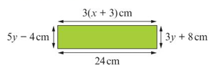

## Solving Inequalities

Solve like equations but remember to reverse inequality when multiplying/dividing by **negatives**.  
Examples:  
a) -3x < 9  
x > -3

b) Copy each number line and show each inequality on the number line.

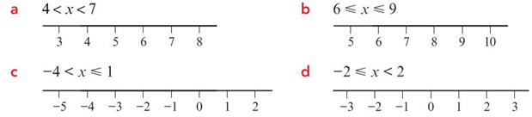

ACTIVITIES: Cambridge Lower Secondary Mathematics Workbook 8

Ex. 2.1, pg, 15, No.6

Ex. 2.3, pg 23,No.8

Ex. 2.4, pg 27, No. 10

ASSIGNMENT: Cambridge Lower Secondary Mathematics Workbook 8

Ex. 2.1, pg, 15, No.5

Ex. 2.2, pg 21, No. 16

Ex. 2.5, pg 33, No. 10

Ex. 2.6, pg 39, No. 14

**Week 4 Sequences and Functions**

**Generating Sequences:**

Example: Find the term-to-term rule and the next two terms of this sequence:

* + 1. 5, 5, , ….
    2. 17, 16.2, 15.4, 14.6, …

Find rules for sequences:

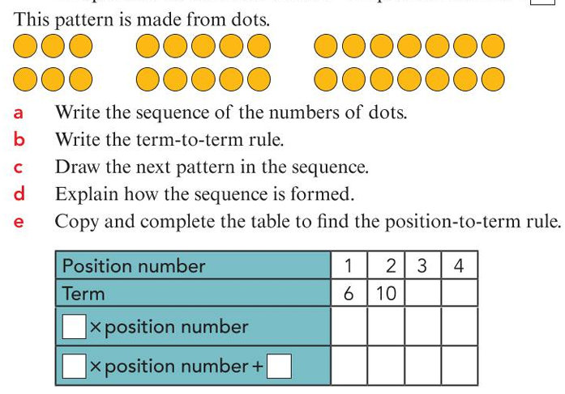

**Using the nth term**:

The nth term expression of a sequence is 2n – 1. Work out the first three terms and the tenth term of the sequence.

**Example:** Work out the nth term expression for these sequences:

1. 7, 10, 13, 16,…
2. 18, 15, 12, 9, …

**Representing Simple Function**

A function is a relationship between two sets of numbers.

Example 1 : Copy and complete this table. And write this function as equation.

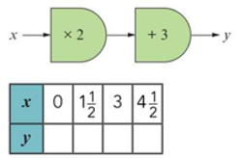

Example 2:

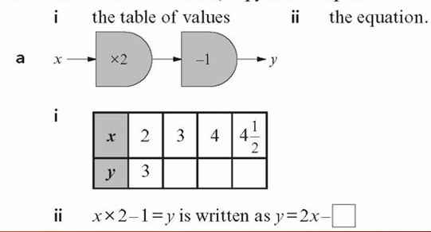

INVERSE OF FUNCTION

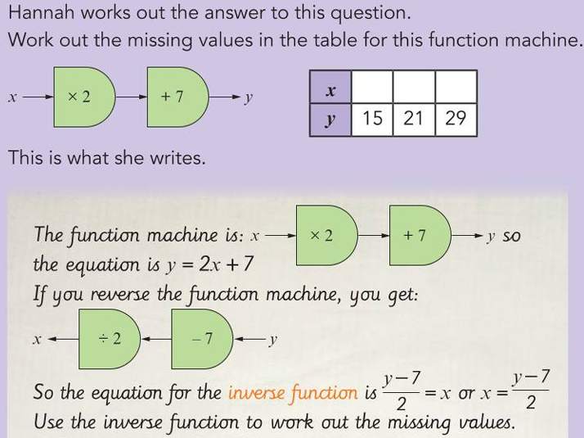

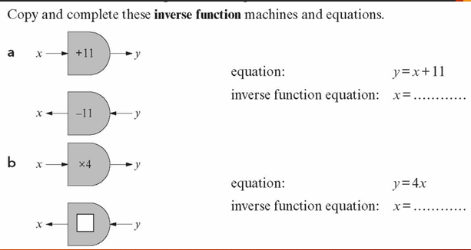

ACTIVITIES: Workbook: Pg 128, Ex.9.4, No. 7

ASSIGNMENT: Workbook: Pg 128, Ex.9.4, No. 8

**WEEK 5: Graphing Linear Functions:**

**Functions**:

Example: The cost of hiring a hall is in two parts> There is a booking fee for #25 and a charge of #200 per hour.

* + 1. The cost of hiring the hall for 4 hours will be #200x4 + #25.
    2. If the hall is hire for n hours and the cost is #C. Then #C $=\#200×n+\#25$.

**Plotting Graphs**

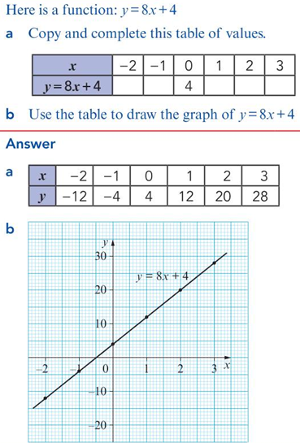

**Gradient and Intercept:**

A function in the form $y=mx+c$ where m (gradient) and c (intercept) are numbers is called a linear function.

Some linear functions and the values of the gradient and intercept.

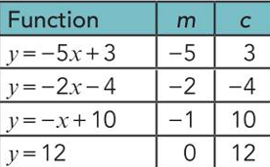

The gradient, also, can be found in the graph and from the table of values.

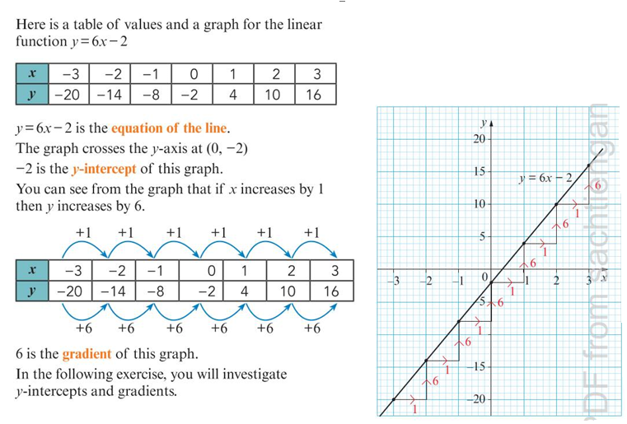

**Interpreting Graphs:**

Cambridge Lower Secondary Mathematics Learner’s Book 8, Ex. 11.4, pg 251

ACTIVITIES: Workbook 8, Ex. 11.2, No.6

ASSIGNMENT: Workbook 8, Ex. 11.2, No. 11

Workbook 8, Ex. 11.3, No. 11

**WEEK 6: GEOMETRY Quadrilateral & Circles**

Hierarchy of Quadrilateral:

A **quadrilateral** is any **four-sided** polygon. Quadrilaterals can have different properties, such as equal sides, equal angles, or pairs of parallel sides. Because of this, they are grouped into a **hierarchy**—a system that shows how one type fits into another, from general to specific.

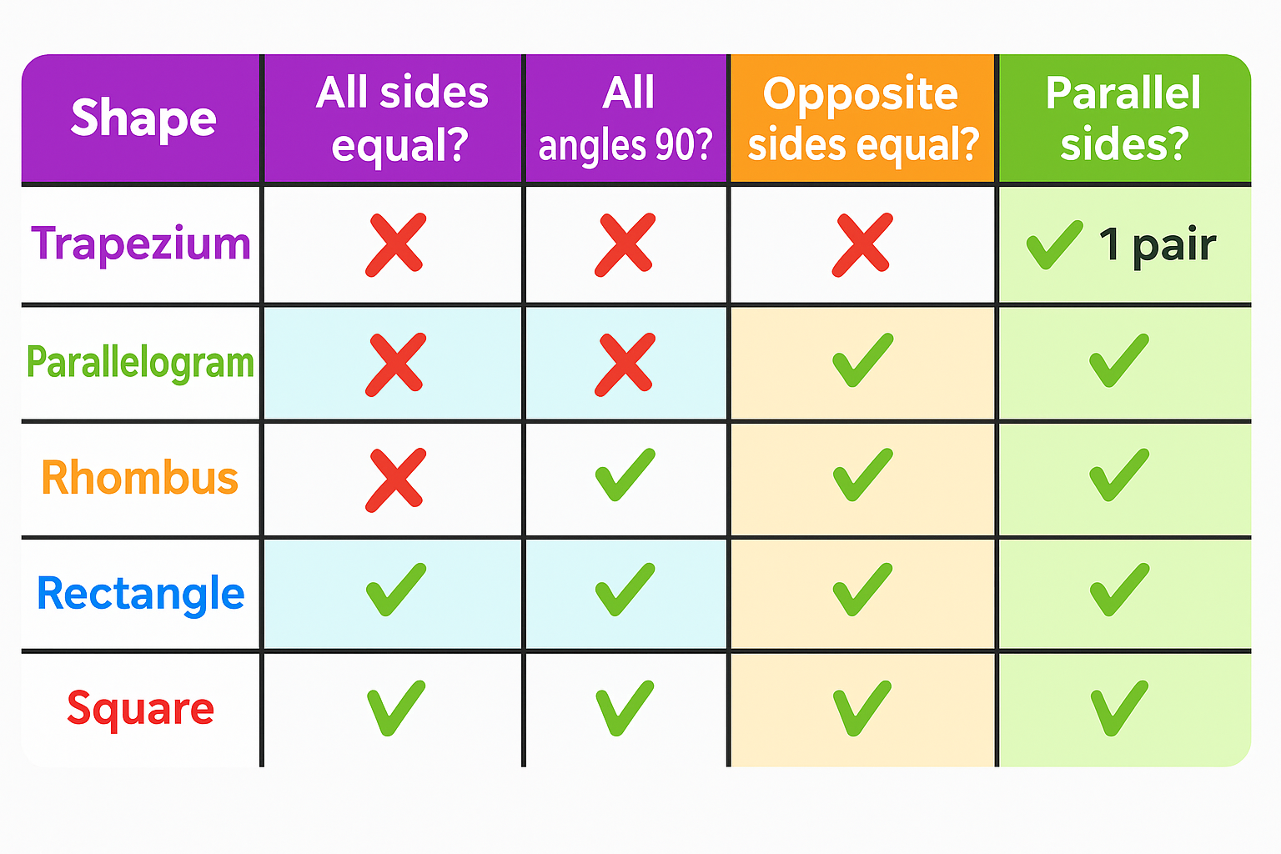

**The Circumference of a Circle**

Copy and complete this table

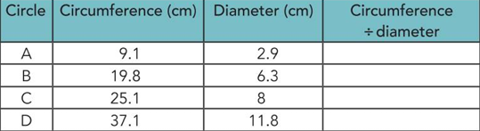

You will notice that all the answers are 3.14 (2 d.p). This means that the ratio of the diameter to the circumference of a circle is 1:3.14. Thus $π=\frac{circumference}{diameter}$.

Example/Class Activity: Work out the perimeter of each compound shape and give your answers correct to two decimal places.

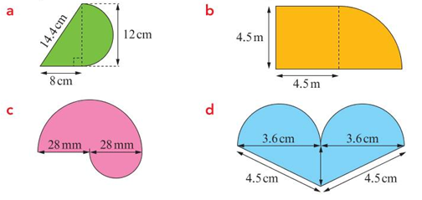

Note: Perimeter is the total distance around the outside of the whole space.

**Miles/Kilometres Conversion**

The kilometre is a shorter unit of measurement than a mile. One kilometre is about 5/8 of a mile.

To convert a distance in kilometres to distance in miles, multiply by 5/8.

To convert a distance in miles to a distance in kilometres, multiply by 8/5 ( or divide by 5/8)

Class Activities: Learner’s Book , Ex. 15.1, pg 333, No. 6a,b and 7a, b

**WEEK 7 MID TERM BREAK**

**WEEK 8 AREA and VOLUME**

The area of Parallelogram = $base×height$

The area of trapezium $=\frac{1}{2}×(a+b)×h$

Example: Find the areas of these shapes:

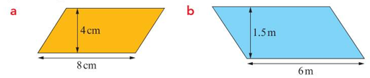

**Euler’s Formula (3D Shapes)**

Euler’s Formula is a mathematical rule used to describe a relationship between the number of faces, edges and vertices of certain 3D shapes (called polyhedral).

Euler’s Formula: $F+V-E=2$

where F – Number of faces, V-Number of Vertices (corners), E – Number of Edges.

Recall: **Face**: A flat surface on a 3D shape. **Edge**: A straight line where two faces meet. Vertex (plural vertices): A point where edges meet (a corner).

Example1 Cube

Faces(F)=6, Vertices (V)=8 and Edges (E) =12

$$F+V-E=6+8-12=2$$

Volume of Triangular Prisms

A cuboid is a rectangle prism. A prism is a 3D shape which has the same 2D shape throughout its length.

Volume = area of the cross-section x length.

Example:

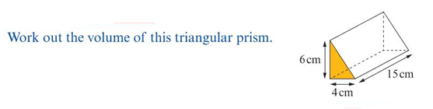

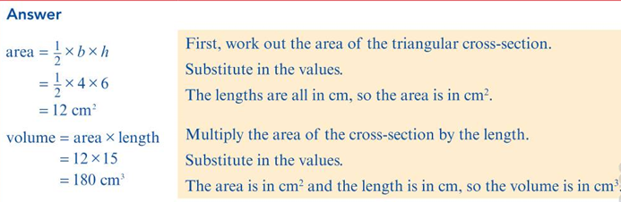

Example/Class Activity: Work out the volume of each triangular prism.

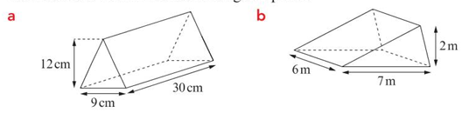

**WEEK 9 GEOMETRY**

**Surface Area of Prisms/Pyramid**

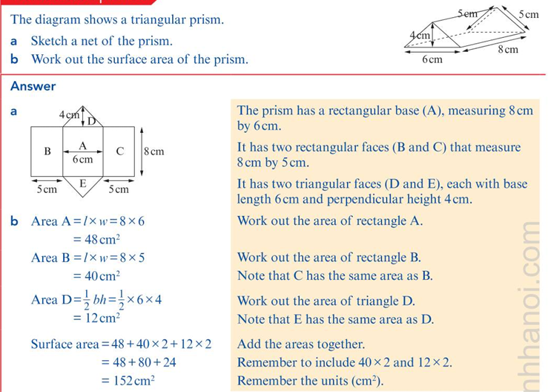

Classwork: Workbook 8, Ex. 15.3, pg 202. No.1-3

Assignment: Workbook, Ex. 15.4, pg 206, No. 1 & 3a,3b

**Symmetry in Polygons**

A regular polygon has same side and same angle. For Instance, a regular pentagon has 5 sides of the same length, 5 line of symmetry and rotational symmetry of order 5.

Example: Copy and complete this table.

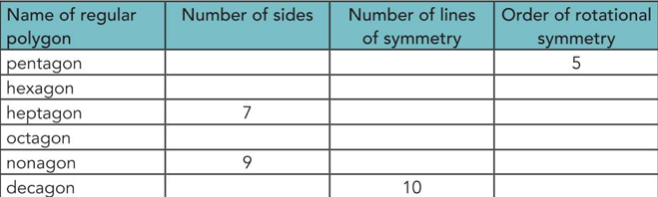

Assignment: Workbook 8, Ex.8.1, pg 96, No.1, 2 and 3.

**WEEK 10: ANGLES & BEARING**

10.1 Exterior Angles of Triangles

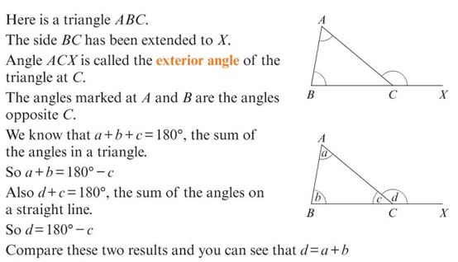

Thus, exterior angle of a triangle = sum of the two interior opposite angles.

Examples/Activities:

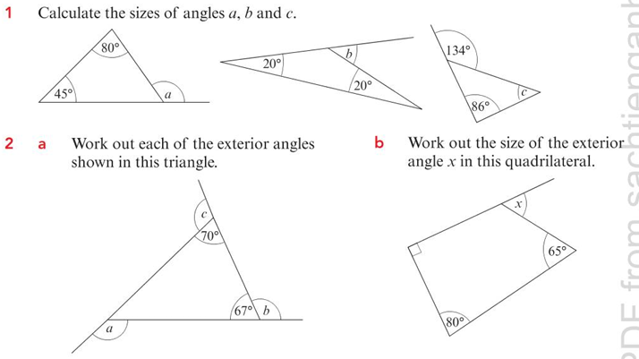

Assignment: Workbook 8, Ex. 5.2, pg 65, No. 3 and 4.

**Bearings**

A bearing describes the direction of one object from another. It is an angle measured from north in a clockwise direction. The angle of bearing is from 0 degree to 360 degree. It is always written in three figures.

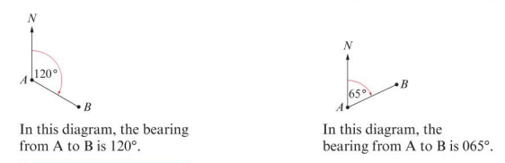

**Activities**: Learners’ Book Ex.14.2, No.1, pg 293.

* 1. For each diagram, write the bearing of B from A. Use protractor to measure the angle from north in a clockwise direction.

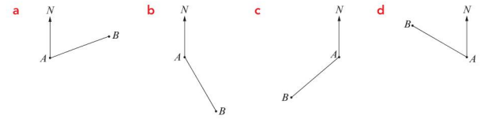

Activities: Learner’s Book pg 296, No. 8, Ex. 14.1

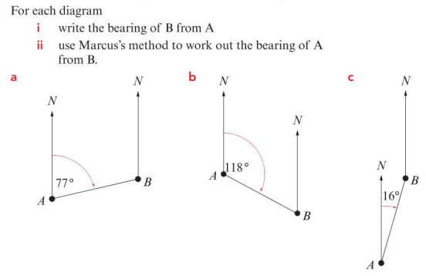

Classwork: Workbook 7, pg 65, Ex. 5.2, No. 1-3

Pg 165, Ex. 14.1 No.1

Assignment: Workbook 7, pg 65, Ex. 5.2, No. 4

Pg 168, Ex. 14.1 No.8

**SECOND TERM**

**Week 1: Transformations I**

**Week 2: Transformations II**

**Week 3: Data Analysis**

**Week 4: Statistics & Probability I**

**Week 5: Statistics & Probability II**

**Week 6: Percentage Increases & Decreases**

**Week 7: MID TERM BREAK**

**Week 8: Interpreting & Data Presentations**

**Week 9: Indices & Standard Form**

**Week 10: Number Operations**

**Week 1: Transformations I**

**Midpoint of a line segment**

The diagram shows two lines segments, AB and CD. The midpoint of AB is halfway between A and B. Fom the diagram the midpoint of AB is (3,3) and the midpoint of CD is (1,0)

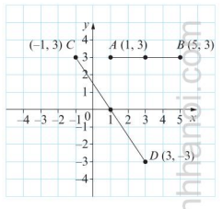

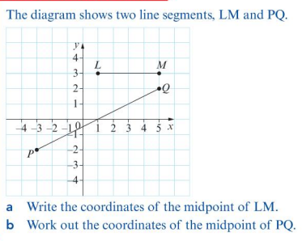

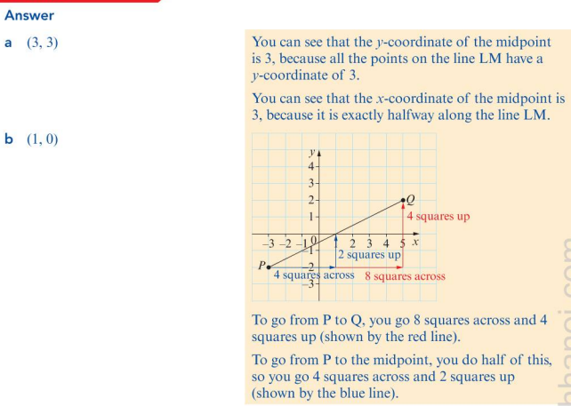

**Translation with vectors**

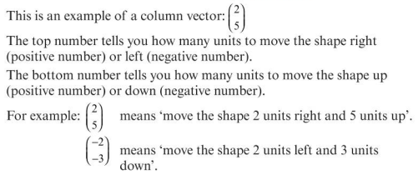

**Classwork**: Workbook 7, pg 175. Ex.14.3 No. 3

**Assignment**: Workbook 7, Ex.14.3pg. 176, No.8

**Reflect shapes in mirror lines**

We learnt reflection using x or y as a mirror, now we need to learn how to reflect shape on a coordinate grid in another mirror. Hence, we shall need to know the equation of the mirror line.

**Note**: All vertical lines are parallel to the y axis and have equation $x=^{'}a constant'$ and horizontal lines are parallel to x-axis and have the equation $y=^{'}a constant'$

Example:

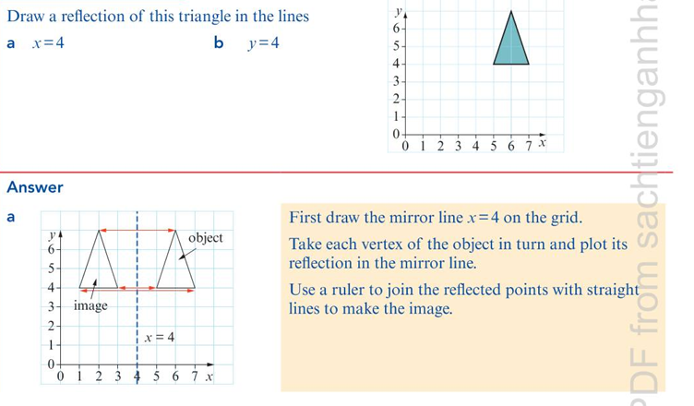

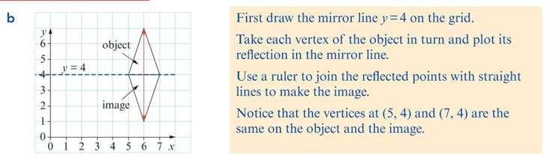

Class Activities: Workbook year 8, Ex. 14.4, No. 1 and 2, pg 178

Assignment: Workbook, Year 8, Ex. 14.4, No. No.4

**Week 2: Transformations II**

**Rotations (centre/angle)**

There are three key information that are required to carry out rotations:

* 1. The angle of rotation.
  2. The direction of rotation (clockwise or anticlockwise)
  3. The coordinates of the centre of rotation.

Example:

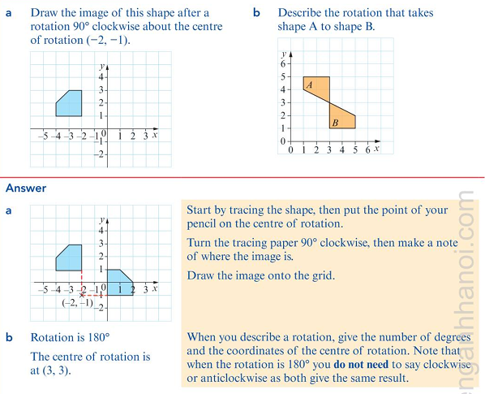

**Enlargements (integer scale)**

An enlargement of a shape is a copy of the shape that changes the dimensions but not the proportions. In enlargement, all angles are the same.

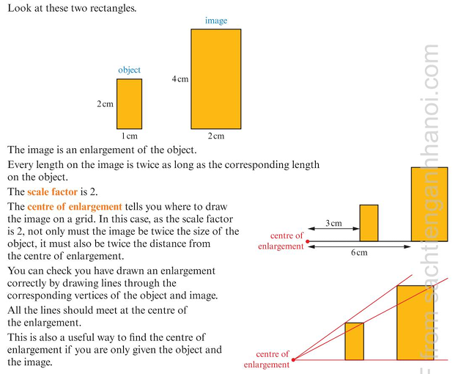

Classwork: Workbook Year 8, Ex. 14.5, pg. 184, No.1

Workbook Year 8, Ex. 14.6, pg 188, No. 1

Assignment: Workbook Year 8, Ex.14.5, pg 184, No. 2

Workbook Year 8, Ex.14.6, Pg 188, No. 2

**Week 3: Data Analysis**

**Justify data collection methods**

Data collection is the process of gathering information to help answer questions or solve problems. In Mathematics, we collect data to **analyze trends**, **make predictions**, or **support decisions**.

Common Data Collection Methods

|  |  |  |
| --- | --- | --- |
| Method | Description | Best Used When… |
| Survey/Questionnaire | Asking people questions and recording their answers | You want to know people’s opinions or preferences |
| Observation | Watching and recording behaviors or events | You want to record actions or patterns (e.g. traffic flow) |
| Experiment | Carrying out a test under controlled conditions | You want to see how one factor affects another |
| Using Existing Data | Using data that is already available (e.g. from books or the internet) | You don’t need to collect new data |
| Interview | Speaking directly to individuals to get detailed information | You need in-depth responses from fewer people |

## How to Justify Your Method:

When choosing a method, ask:  
What question am I trying to answer?  
Who or what am I collecting data from?  
How much time do I have?  
Do I have enough resources?

**Sampling advantages/disadvantages**

Sampling is the process of selecting a smaller group (called a sample) from a larger group (called a population) to gather information. Instead of collecting data from every member of a population, we use a sample to save time and effort.

## Example:

Imagine you want to find out the favourite subject of students in a school with 1,000 students. Instead of asking all 1,000 students, you can select a sample of 100 students to represent the whole school.

## Advantages of Sampling:

* ✔️ Saves time – You don’t have to ask everyone.
* ✔️ Saves money – Fewer resources are needed.
* ✔️ Easier to manage – Working with a smaller group is more practical.
* ✔️ Useful when the population is very large or hard to contact.

## Disadvantages of Sampling:

* ❌ Might not represent the whole population accurately.
* ❌ Can lead to biased results if the sample is not chosen properly.
* ❌ Less accurate than a full population survey.

Classwork: Workbook 8, Ex. 6.1, pg.129, No. 1

Workbook 8, Ex. 6.2, pg 133, No. 1

Assignment: Workbook 8, Ex. 6.1, pg 129, No. 2

Workbook 8, Ex. 6.2, Pg 133, No. 2

**Represent categorical/data**

In Mathematics, data can be grouped into different types depending on what is being measured or observed. The three common types are categorical, discrete, and continuous data.

## 1. Categorical Data

Categorical data describes qualities or labels that can be sorted into groups. It is not numerical.

**Examples**:

Hair colour: black, brown, blonde

Type of car: SUV, sedan, truck

Day of the week: Monday, Tuesday, etc.

## 2. Discrete Data

Discrete data is numerical and consists of whole numbers. It represents values that can be counted one by one.

**Examples**:

* 1. Number of students in a class
  2. Number of goals scored
  3. Number of books on a shelf

## 3. Continuous Data

Continuous data is numerical and can take any value within a range. It is often measured and can include decimals or fractions.

**Examples**:

* 1. Height of students
  2. Temperature during the day
  3. Time taken to run a race

**Compare distributions**

## What Does It Mean to Compare Distributions?

To compare distributions means to look at two or more sets of data and describe how they are similar or different. This helps us understand trends, patterns, or differences in the data.

## What Should We Compare?

When comparing distributions, look at the following features:

Range – The difference between the highest and lowest values (shows the spread).

Mode – The most frequent value (helps find the most common result).

Median – The middle value when the data is in order (shows the central tendency).

Mean – The average value (another way to find the center).

Shape – Are the data values spread out or grouped together? Symmetrical or skewed?

## Example:

Two classes took a Mathematics test. Here are their scores:

Class A scores: 65, 68, 70, 70, 72

Class B scores: 50, 60, 70, 80, 90

Let's compare:

**Mean**:

- Class A: (65 + 68 + 70 + 70 + 72) ÷ 5 = 69

- Class B: (50 + 60 + 70 + 80 + 90) ÷ 5 = 70

**Range**:

- Class A: 72 - 65 = 7

- Class B: 90 - 50 = 40

**Median**:

- Class A: 70 (middle number)

- Class B: 70 (middle number)

**Mode**:

- Class A: 70 (appears twice)

- Class B: No mode (all numbers appear once)

## Conclusion:

Even though both classes have the same median and similar means, Class B has a much wider range. This means the students in Class B performed very differently, while Class A students performed more consistently.

**Week 4: Statistics & Probability I**

**Complementary events**

Complementary events are two outcomes that covers all possibilities in a situation. If one event does not happen the other must happen.

If A is an event and A’ is the complementary event, then P(A’) = 1 – P(A).

Examples:

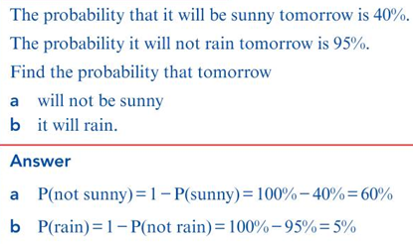

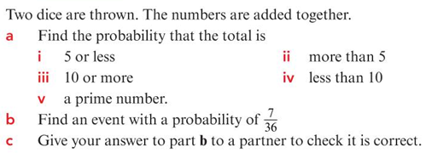

**Combined events (independent)**

When **two or more events happen together**, and the outcome of one **does not affect** the outcome of the other, they are called **independent events**.

For **independent events**, the probability of both events happening is found by **multiplying** their individual probabilities:

$$P\left(A and B\right)=P\left(A\right)×P\left(B\right)$$

Example:

**Tossing a coin and rolling a die:**

Probability of getting a head = 0.5

Probability of rolling a 4 = 1/6

Combined probability =P(Head and 4) = P(Head) x P(4)

=0.5 x 1/6

**EXPERIMENTAL PROBABILITY**

A spreadsheet is used to simulate throwing a dice 100 times and here are the results of the experiment.

|  |  |  |  |  |  |  |
| --- | --- | --- | --- | --- | --- | --- |
| Score | 1 | 2 | 3 | 4 | 5 | 6 |
| Frequency | 15 | 18 | 19 | 16 | 17 | 15 |

We can work out the experimental probabilities from the table.

The probability of throwing 4 is 16/100=0.16

The probability of odd number is $\frac{15+19+17}{100}=\frac{51}{100}=0.51$

Class Activities: Workbook 7, Exercise 13.1, pg 159, No. 1 and 2

Assignment: Workbook 7, Exercise 13.1, pg 160, No. 8

Workbook 7, Exercise 13.2, pg. 163, No.4

**Week 5: Statistics & Probability II**

**Probabilities of combined events**

A **combined event** involves calculating the probability of **two or more events** happening together. The method you use depends on whether the events are **independent** or **dependent**, and whether you’re dealing with **AND** or **OR** situations.

**AND (Both Events Happen)**

For **independent events**: $P\left(A and B\right)=P(A)×P(B)$

**OR (Either Event Happens)**

* For **mutually exclusive events** (they cannot both happen):

$$P\left(A or B\right)=P\left(A\right)+P(B)$$

Example: A bag has 3 red, 2 blue, and 5 green balls. What’s the probability of picking a red **or** blue ball?

**Week 6: Percentages Increase and Decrease**

Percentage Increase $=\frac{Increase}{original Price}×100$

Percentage Decrease $=\frac{Decrease}{Original Price}×100$

Example: The population of a town is 45 000. The population is expected to rise by 85% in the next ten years. Estimate the population in ten years’ time.

Using Multiplier:

$$Multiplier= \frac{New value}{original valu}$$

Example:

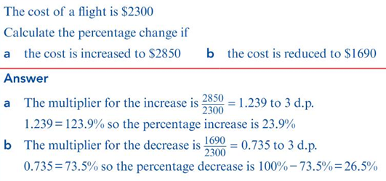

Example: Find the multiplier for an increase of i) 5% b) 95%

Example: Find the multiplier for a decrease of a) 14% b) 67%

Example: The price of bread is #2000, using multiplier, calculate its new price if there is 5%.

Class Activities: Ex.10.1, pg 131, No.9, EX. 10.2, No.3, pg 132

Assignment: EX. 10.2, No.10, pg 133

**WEEK 7 MID TERM BREAK**

**WEEK 8: Interpreting and Data Presentations**

**Common Terms:**

**Frequency Diagram**  
A chart (like a bar chart or histogram) that shows how **often (frequency)** each data value or group of values occurs.

**Grouped Data**  
Data that has been **organized into groups (classes)** instead of listing every individual value. This is useful for large sets of data.

**Class Intervals**  
The **ranges** used in grouped data to divide values into sections (e.g. 0–10, 11–20). Each interval includes a group of values.

**Discrete Data**  
Data that can take **specific separate values**, usually **whole numbers** (e.g. number of students, goals scored).

**Continuous Data**  
Data that can take **any value within a range**, including **decimals or fractions** (e.g. height, weight, time).

When you draw a bar chart for discrete data, ensure the following:

* 1. The bars are all the same width.
  2. The gaps between the bars are equal.
  3. The frequency diagram is title and the axes are label.
  4. Use reasonable scale on the vertical axis

When you draw a bar chart for continuous data, ensure that:

1. the class intervals are all the same width.
2. There are no gaps between the bars.
3. Reasonable scale is used on the horizontal axis.
4. The diagram is title and the axes label correctly

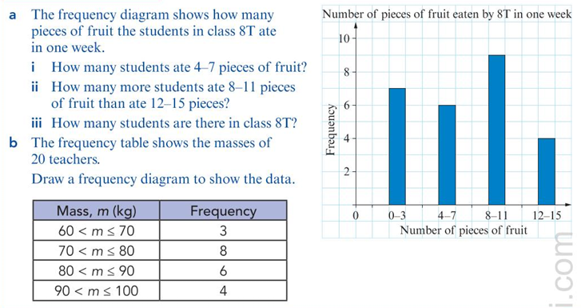

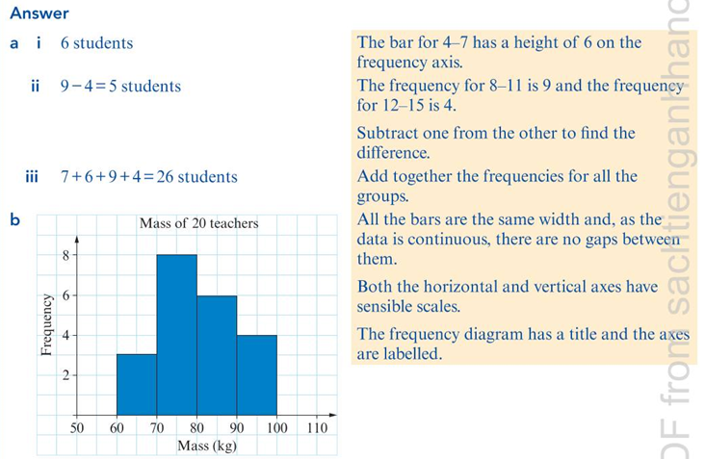

Class Activities: Learners’ Book, Ex. 16.1, pg 357, No.1 and 2

Time Series Graph

A **time series graph** is a **line graph** that shows how **data changes over time**.

* The **horizontal axis (x-axis)** represents **time** (e.g., days, months, years).
* The **vertical axis (y-axis)** represents the **quantity being measured**.

When drawing time series graph, ensure that you;

1. Put time on the horizontal axis
2. Use an appropriate scale on the vertical axis.
3. Plot each point accurately.
4. Join the points with straight lines
5. Give the time series graph a title and label the axes

Example:

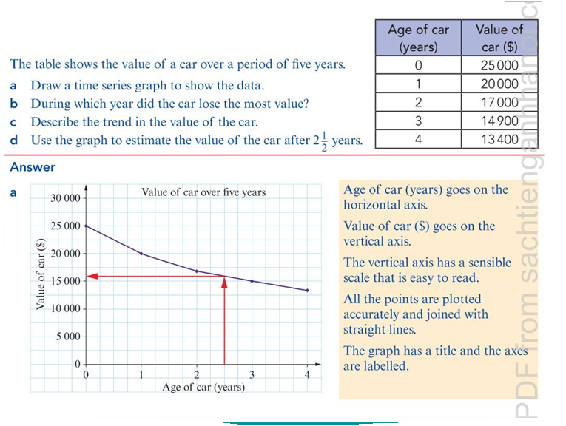

**STEM-and LEAF-DIAGRAM**

A **stem-and-leaf diagram** is a way of **organising and displaying numerical data** so that you can quickly see the **shape and spread** of the data.

Key Features:

Ensure you write the number in order of size from smallest to largest.

You write a key to explain the numbers.

You keep all the numbers in line vertically and horizontally.

Example:

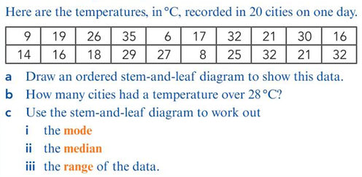

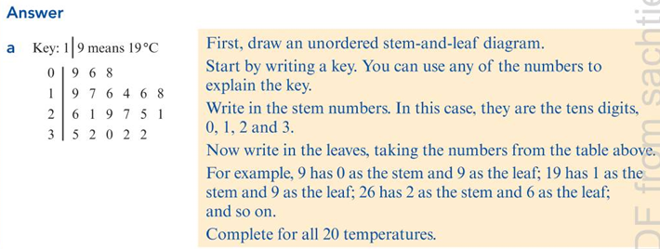

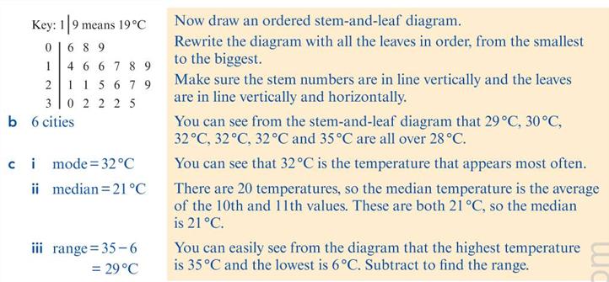

Class Activities: Workbook 8, Ex. 16.2, Pg 214, No. 1 & Ex. 16.3, pg. 219, No. 1

Assignment: Workbook 8, Ex. 16.2, Pg 214, No. 2 & Ex.16.3, pg. 220, No.6

**Week 9: Indices & Standard Form**

Rational/Irrational Numbers

A rational number is any number that can be written as a fraction $\frac{a}{b}$, where a and b are integers but $b≠0$. Examples: Integers (-3, 0, 7), Fractions (2/3, -5/3), Terminating decimals (0.75=3/4)

An irrational number cannot be written as a simple fraction. It decimal form never ending and does not repeat. $π≈3.14159…$, $\sqrt{2}≈1.414213…$, $\sqrt{5}$, $\sqrt{3}$ (non-perfect square roots)

Index laws (negative/zero indices)

The table shows power of 3

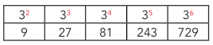

When you move one column to the right, the index increases by 1 and the number multiplies by 3. When you move one column to the left, the index decreases by 1 and the number divides by 3. You can use this fact to extend the table to the left.

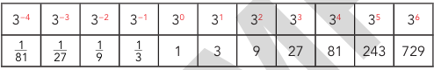

In general, if n and a are positive integers, $a^{0}=1$ and $a^{-n}=\frac{1}{a^{n}}$

Class Activities: 1) Write each as a fraction: a) b)

* 1. Write these number as power of 2: a) $\frac{1}{64}$ b) 64 c) $8^{-1}$

Standard form

**Standard form** (also called **scientific notation**) is a way of writing **very large or very small numbers** using powers of 10.

Standard Form: $a×{10}^{n}$ where 1 $≤a≤10$, where n is an integer (positive or negative)

$$4500000=4.5×{10}^{6}$$

$$0.00032=3.2×{10}^{-4}$$

**Estimate surds**

A **surd** is a number that **cannot be simplified to a whole number or a fraction** — usually a square root of a number that is **not a perfect square**.Since they cannot be simplified exactly, we **estimate** them using **whole numbers between which they lie**.

Example 1: Estimate $\sqrt{10}$.

Solution: First find the two nearest perfect squares above and below the surd. $\sqrt{9}=3$ and $\sqrt{16}=4$. The square root of $\sqrt{10}$ lies between 3 and 4. Therefore, $\sqrt{10}≈3.16$.

Example 2: Estimate $\sqrt{20}$.

Solution: $\sqrt{16}=4$ and $\sqrt{25}=5$. The $\sqrt{20}$ lies between 4 and 5. Therefore, $\sqrt{20}≈4.47$

Class Activities: Estimate the following: 1) $\sqrt{2}$ 2) $\sqrt{5}$ 3) $\sqrt{10}$

**Week 10: Number Operations**

**Upper/lower rounding limits**

When a number is **rounded**, it could have been **a little more or a little less** than the value written. The **upper and lower bounds** tell us the **range of possible actual values** before rounding.

**Key Features**:

**Lower Bound**: The **smallest value** that could round to the given number.

**Upper Bound**: The **largest value** that could round to the given number.

The actual value lies **between** the upper and lower bounds.

**If a number is rounded to the nearest whole number:**

* Lower Bound = number − 0.5
* Upper Bound = number + 0.5

**If a number is rounded to 1 decimal place:**

* Lower Bound = number − 0.05
* Upper Bound = number + 0.05

Example: 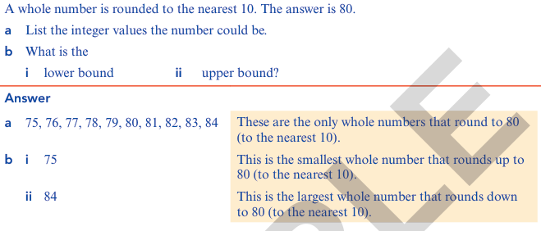

Example:

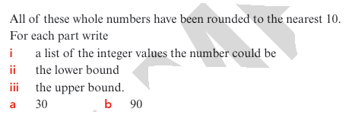

**Recurring/terminating decimals**

Decimals can either **end** (terminate) or **continue forever** in a repeating pattern. Understanding the type of decimal helps us know whether it can be written as a **fraction**.

**Terminating Decimals**

A **terminating decimal** is a decimal that **comes to an end** — it has a **finite number of digits** after the decimal point.

**Examples:**

* 0.5
* 3.75

$\frac{1}{4}=0.25$

### **Recurring Decimals**

A **recurring decimal** is a decimal that **goes on forever** but has a **repeating pattern**.

**Examples:**

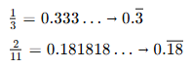

**Note**: A fraction in **simplest form** will have a **terminating decimal** **if and only if** the **denominator has no prime factors other than 2 and/or 5**.

* If the denominator (after simplification) contains **only 2s and/or 5s**, the decimal **terminates**.
* If the denominator contains **any other prime factor** (like 3, 7, 11, etc.), the decimal **recurring decimal.**

Class Activities: Workbook 8, Pg. 75, Ex.7.1, No. 5

Workbook 8, Pg 76, Ex.7.1, No. 14 a & b

Assignment: Workbook 8, Pg 76, Ex.7.1, No. 14 c & d

THIRD TERM

**WEEK 1: RATIOS AND PROPORTIONS**

**WEEK 2: ALGEBRAIC EXPRESSIONS I**

**WEEK 3: ALGEBRAIC EXPRESSIONS II**

**WEEK 4: EQUATIONS AND INEQUALITIES**

**WEEK 5: SEQUENCES AND FUNCTIONS**

**WEEK 6: GRAPHING AND FUNCTIONS**

**WEEK 7: MID TERM BREAK**

**WEEK 8: SHAPE AND MEASUREMENT**

**WEEK 9: VOLUME, SURFACE AREA AND SYMMETRY**

**WEEK 10: TRANSFORMATION**

**Week 1: Proportion & Ratio**

Direct/inverse proportion

Direct Proportion: Two quantities are said to be in **direct proportion** if **as one increases, the other also increases at the same rate**.

Mathematically, if x is directly proportional to y, we write $x α y$ which is same as $x=k y$ where k is a constant of proportionality.

Inverse Proportion: Two quantities are in **inverse proportion** if **as one increases, the other decreases** in such a way that their **product remains constant**. Mathematically, if x is inversely proportional to y, we write $x∝ \frac{1}{y}$ where $xy=k$ k is the constant of proportionality.

Example:

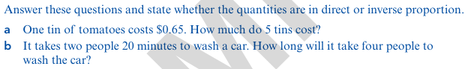

Example: It takes 6 people 4 hours to sort and pack a load of eggs. How long will it take 10 people to sort and pack the same number of eggs? Give your answer in hours and minutes.

**Ratio equivalence**

**Ratio Equivalence** means that two or more ratios represent the same relationship or proportion, even though the numbers may look different. Two ratios are **equivalent** if they have the same value when simplified or written as fractions.

**Arithmetic laws (integer powers)**

**Integer powers** involve multiplying a number by itself repeatedly. Arithmetic laws (also called laws of indices or exponent rules) help us simplify expressions with powers.

* 1. Product law: $a^{m}×a^{n}=a^{m+n}$
  2. Quotient law: $a^{m}÷a^{n}=a^{m-n}$ $a≠0$
  3. Power of product rule: ${(a^{m})}^{n}=a^{mn}$
  4. Power of Product Rule: ${(ab)}^{n}=a^{n}b^{n}$
  5. Power of Quotient rule: ${\left(\frac{a}{b}\right)}^{n}=\frac{a^{n}}{b^{n}}$, $b≠0$
  6. Zero index rule: $a^{0}=1$
  7. $a^{-n}=\frac{1}{a^{n}}$**, $a≠0$**

**Example/Class Activities/Assignment:**

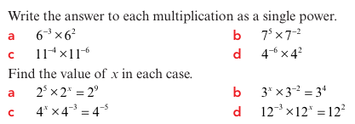

**Week 2: Algebraic Expressions I**

**Substituting into Expression**

When you substitute number into expression, remember to still use the order of operation.

Example:

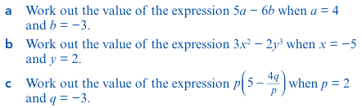

**Constructing Algebraic Expressions**

In Mathematics, letters are used to represent the unknown so that the problem can be solved easily.

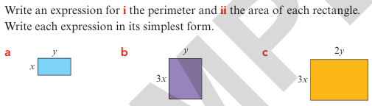

**Expression and Indices**

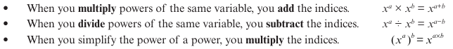

**Example:**

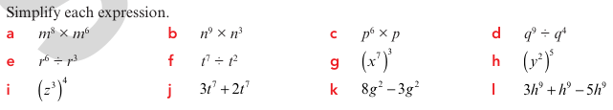

**Class Activities/Assignment:**



**Assignment:**

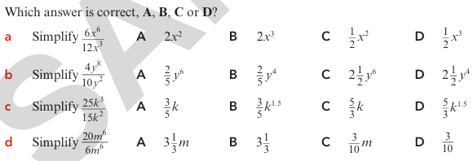

**Expanding the product of two linear expressions**

When you multiply together two expressions in brackets, you must multiply each term in the first pair of brackets by each term in the second pair of brackets.

Example/Class Activities/Assignment:

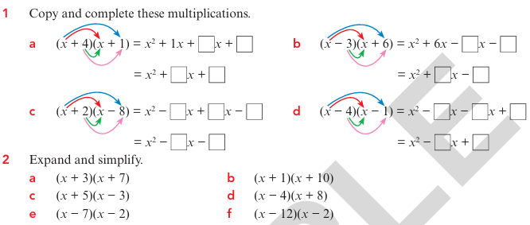

**Week 3: Algebraic Expressions II**

Simplifying Algebraic Fractions

Algebraic Fractions is a fraction that contains unknown variables.

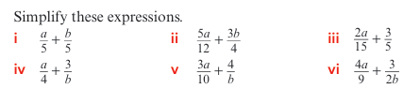

Assignment:

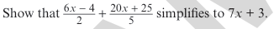

**Deriving and using formulae**

A formula is a mathematical rule that shows the relationship between two or more variables. For instance, a formula $A=πr^{2}$, in this formula, A is the subject of the formula. It is written on its own, on one side of the equation. Depending on what you want to find, you may need to rearrange the formula and this is called change of subject formula.

Example:

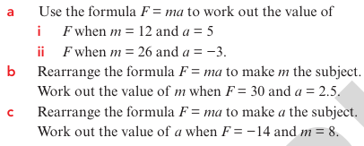

Assignment:

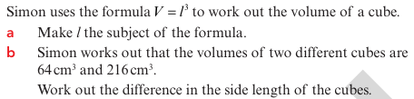

**Week 4: Equations and Inequalities**

**Constructing and Solving Equations**

When you are given a problem to solve, you can construct, or write, an equation to help you solve the problem.

Example:

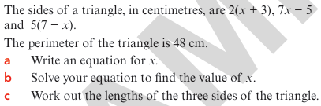

**Simultaneous equations**

**Simultaneous equations** are a set of two (or more) equations that share the same variables and are solved together to find a common solution.

Methods of Solving:

* 1. Substitution Method
  2. Elimination Method
  3. Graphical Method

**Substitution Method**: This is a way of solving simultaneous equations by solving one of the equations for one variable. Then substituting that expression into the other equation.

Example: Solve the following simultaneous equations (using substitution Method):

a) $y=5x-3;y=2x+15$ b) $x+2y=17; 3x=4y+11$

Elimination Method: This involves adding or subtracting the equations to eliminate one variable, making it easier to solve.

Example: Solve the following simultaneous equations (using Elimination Method):

a) $y-5x=-3;y-2x=15$ b) $x+2y=17; 3x=4y+11$

Class Activities:

* + 1. Solve, using substitution Method, $x+4y=41;x+2y=23$
    2. Solve, using elimination Method, $3x+2y=38 ;3x-y=26$

Assignment:

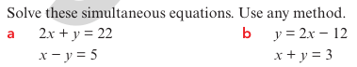

**Linear inequalities**

A **linear inequality** is a mathematical statement that compares two expressions using **inequality symbols** instead of an equal sign.

Example: Write an inequality to describe each of these solution sets.

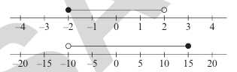

Example: Show each of these solutions on the number line:



Class Activities:

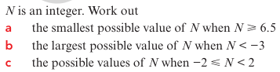

Example: Solve $-1<x+5≤4$ and represents your answer on a number line.

Class Activities: Solve these inequalities and represent each answer on a number line. a) $4<x+2≤7$ b) $-1≤y-6≤14$ c) $-15<5m<30$

**Week 5: Sequences & Functions**

**Linear/quadratic sequences**

In a linear sequence, the terms increase (or decrease) by the same amount each time. In a non-linear sequence, the terms increase (or decrease) by a different amount each time.

Example: Write whether each sequence is linear or non-linear.

* 1. 11, 15, 19, 23, 27,… c) 20, 18, 15, 11, 6, ….
  2. 4, 5, 7, 10, 14, …. d) 20, 12, 4, -4, -12

**nth term rules**

Recall: (linear sequence): Work out the nth term rule for the sequence 6, 8, 10,….

Example: Work out the first three terms and the 10th term of the sequence with nth term a) $n^{2}-1$ b) $5n^{2}+3n$

Example: Work out the nth term rule for the sequence 2, 5, 10, 17, 26,….

**Note**: If the second difference are the same, it is a quadratic sequence, so the nth term rule contains $n^{2}$

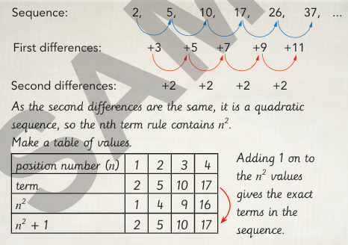

Class Activities/ Class work: Work out the nth term rule of these sequences:

* 1. 4, 7, 12, 19, 28,…. b) 11, 14, 19, 26, … c) $-8, -5, 0, 7, 16$

**Functions**

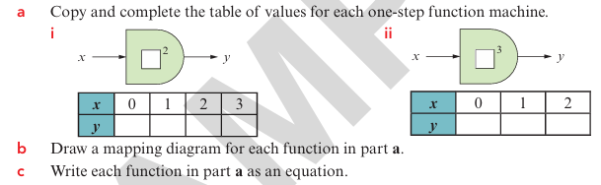

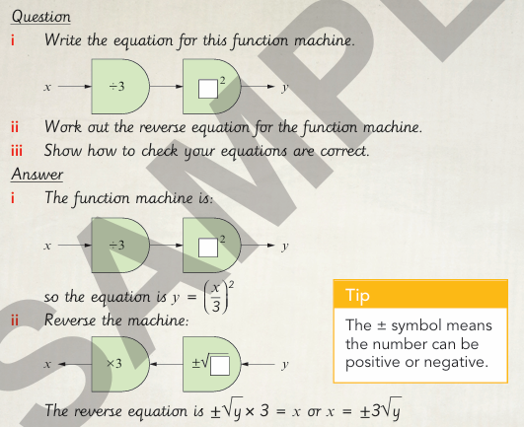

**Assignment:**

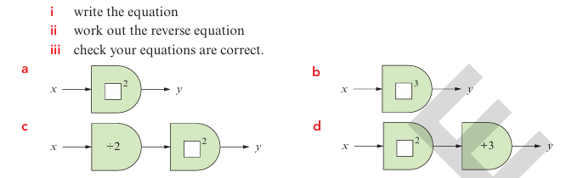

**Week 6: Graphing & Functions**

**Functions:**

* + 1. The cost of hiring a ladder is a fixed charge of $10 plus $3 per day. Work out the cost of hiring a ladder for one week.
    2. The cost of hiring a chainsaw is a fixed charge of $15 plus $10 per da. Aran pays $45, for how many days does he hire the chainsaw?

**Plot quadratic graphs**

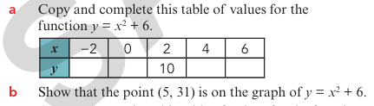

**Straight-line graphs (fractional gradients**)

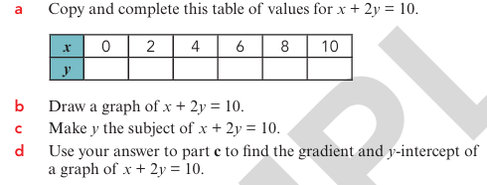

Class Activities:

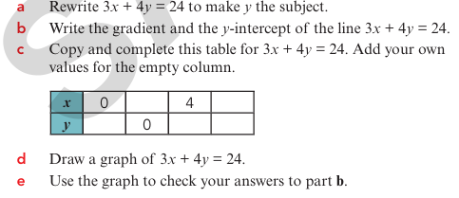

**Week 7: MID TERM BREAK**

**Week 8: Shapes and Measurements**

**Areas of compound shapes**

The method to work out the area is the same:

1 Divide the compound shape into simple shapes.

2 Work out the area of each simple shape.

3 Add or subtract the areas of the simple shapes to find the required area.

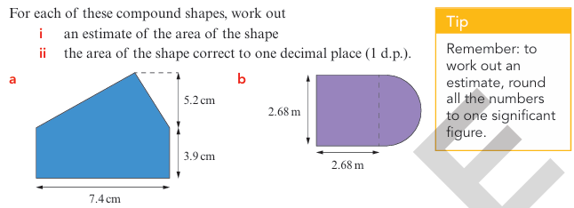

Class Activities/Assignment:

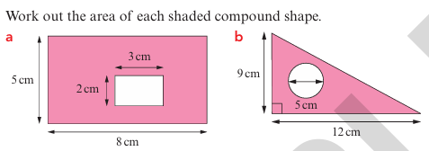

**Small/large measurement units**

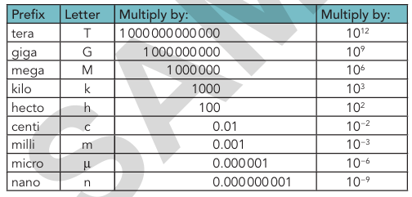

Class Activities/Assignment:

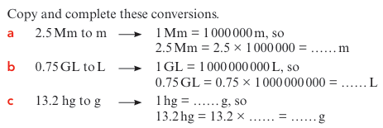

**Week 9: Volume, Surface Area and Symmetry**

**Calculating the Volume of Prisms.**

Prism is a 3D shape that has the same cross-section along its length. Here are some examples of prisms.

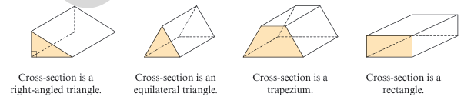

Example:

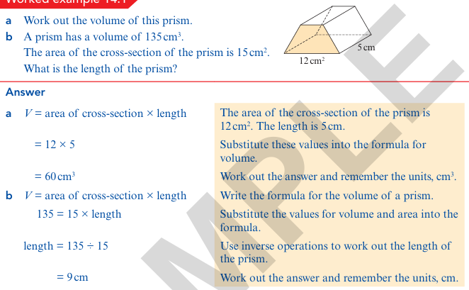

Class Activities:

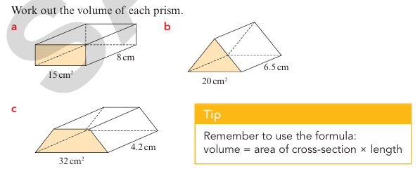

Assignment:

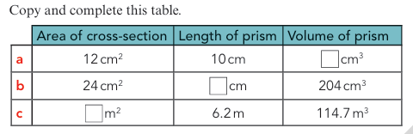

**Calculating the surface area of triangular prisms, pyramids and cylinders**

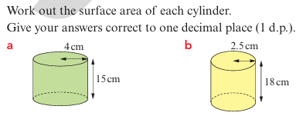

**Symmetry in three-dimensional shapes**

Three-dimensional shapes can be symmetrical. For example, this chair is symmetrical. Instead of a line of symmetry, a 3D shape has a plane of symmetry. In three dimensions, a plane of symmetry divides a solid into two congruent parts.

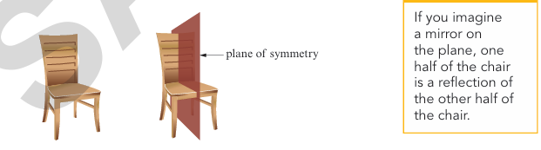

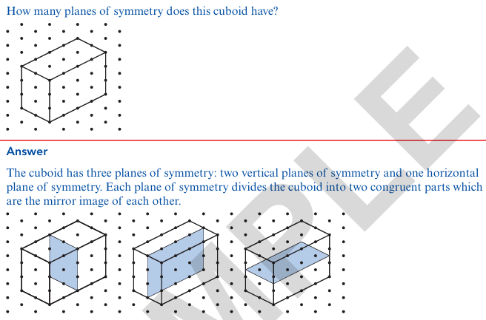

Example/Class Activities:

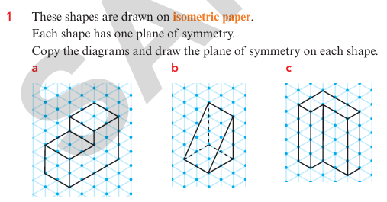

Assignment:

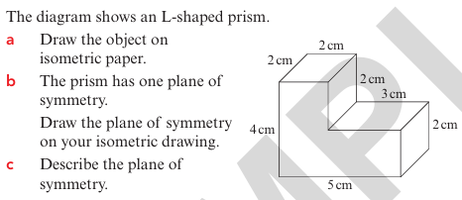

**Week 10: Transformation**

**BEARING AND SCALE DRAWING**

Example:

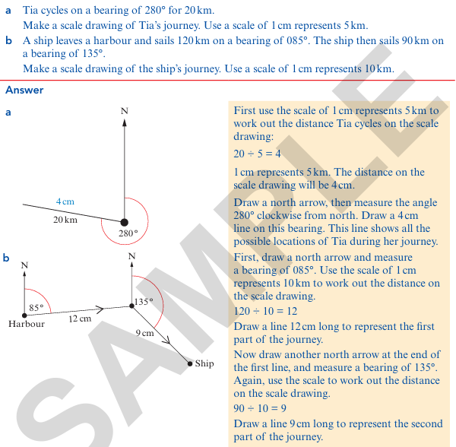

**POINTS ON A LINE SEGMENT**

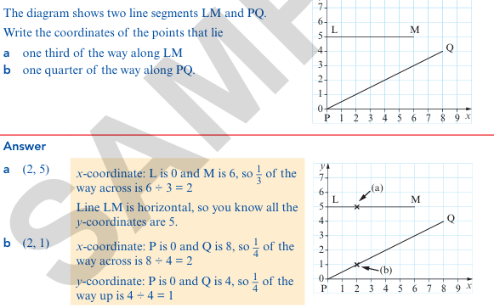

**Transformation**

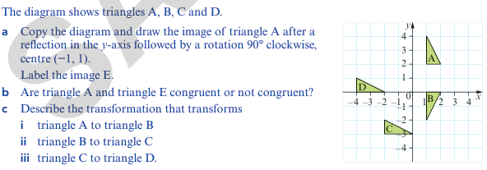

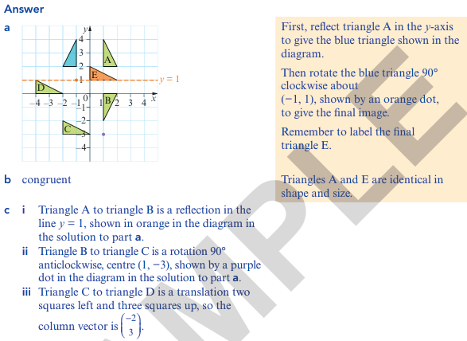

**Enlarging Shapes**

Example/Class Activities/Assignment

